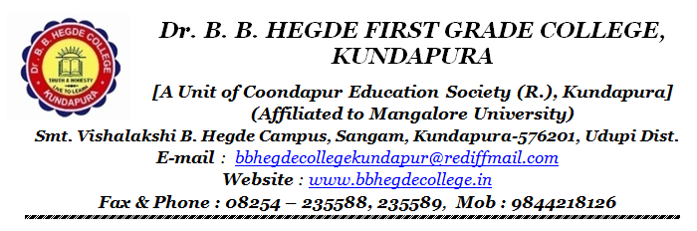
Perspective Document 2016 – 17 To 2020 – 21

Introduction:
Dr. B. B. Hegde First Grade College was established with the noble objectives of Ensuring quality higher education to the socio-economically disadvantaged section of the society. This is achieved through continuous efforts of the college with the support of Coondapura Education Society. The perspective plan for the five years has been prepared to guide the activities of the college to achieve the vision of the Foundation and the vision and mission of the college.

Core of perspective Plan:
- Up-gradation and modification of infrastructure.
- Making provision for the expansion of curricular base.
- Student centric teaching learning pedagogy.
- Enhancing the employability skills.
- Strengthening integration of sports, cultural and academic activities
- Involvement and expansion of community services.
- Industry academia Blend.
- Research and MoU and linkages with relevant academic Institutions and Industries.

Detailed implementation plan:
❖ Infrastructural up gradation and modification:
- Construction of new block.
- Construction of auditorium and science labs.
- Expansion of library.

❖ Expanding the curricular base.
- Introducing new UG programs and certificate courses.

- Student Centric teaching learning pedagogy.
- Planned classroom teaching.
Indicators:
▪ Teachers’ diary
▪ Attendance books with the relevant materials and content.

❖ Integration of sports and cultural activities:
- Enabling the students to represent the college, university and the country in cultural and sports events.
Indicators:
▪ Number of students participated and won prizes at university and national level.
▪ Number of awards received at university and national level

- Community involvement:
- Initiation of extension activities of the departments for the benefit of the community in and around.
- Indicator: Extension activity at various community and social organization is effectively implemented.

- Industry academia integration:
- Guest lecture.
- Internship.
Indicator:
▪ MoU and working documents.
▪ Introduced compulsory internship programs

Five years’ strategic plan (2021 – 22 To 2025 – 26) :
1. Sustainability of the courses and programmes.
2. Expanding the student diversity in various courses.
3. Introducing of comprehensive academic evaluation system.
4. Strengthening ICT based teaching learning.
5. E- Governance.
6. Spreading out the Entrepreneurship programme with the academic programmes.
7. Strengthening and expansion of research activities.
8. Effective employee evaluation system which is integrated in to academic mechanism
9. Strengthening the alumni association and mobilizing funds through the association.
10. Achieving autonomy in academic programmes.

